**Assignments: 05**

**Name: M. ABDULLAH**

**ID: BIT-23F-024**

**Section: BSIT 3A**

**Subject: AI**

**LAB no: 05**

Q1: Print Numbers with Loops: Write a program that uses a loop to print numbers from 1 to 10.

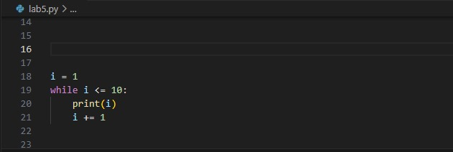

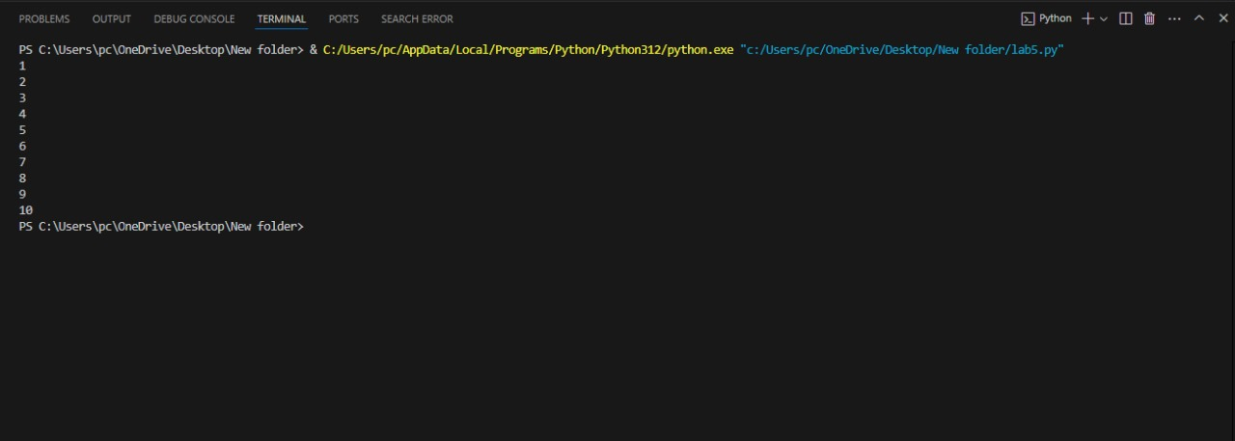

Q2. Calculate the Sum of Numbers: Write a function that calculates the sum of all numbers up to a given number using a loop.

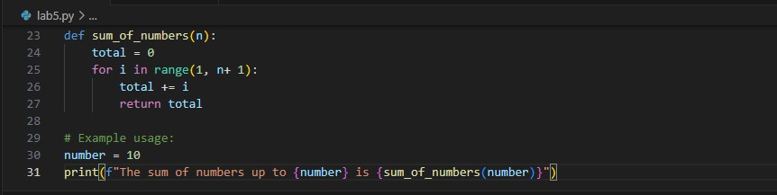

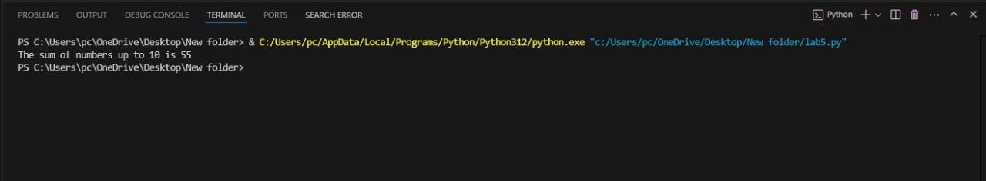

3. Display a Star Pattern: Write code using loops and nested loops to create star pattern (discussed previously).

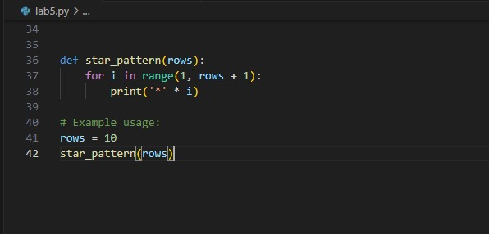

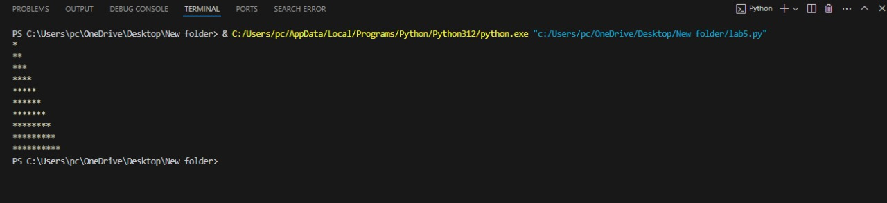

4. Find Even Numbers in a List: Write a function that takes a list of numbers and prints only the even numbers.

